

## PYTHON PROJECT REPORT

**Pest Detection Management Systems for Agricultural Sustainability**

***Submitted by***

**KANISKA S**

**2303722810622059**

**BACHELOR OF ENGINEERING**

## *in*

**ELECTRONICS AND COMMUNICATION ENGINEERING**

**SRI ESHWAR COLLEGE OF ENGINEERING**

**(AN AUTONOMOUS INSTITUTION)**

**COIMBATORE – 641 202**

**JUNE - JULY 2024**

**BONAFIDE CERTIFICATE**

Certified that this project report **“ Pest Detection Management Systems for Agricultural Sustainability** ” is the bonafide work of

KANISKA S

2303722810622059

who carried out the project work under my supervision

|  |  |
| --- | --- |
|  | …………………………………  **SIGNATURE**  **Dr.V.Kiruthika,ME.,MBA., Ph.D.,**  **Assistant Professor**  **Department of Electronics and Communication Engineering,**  **Sri Eshwar College of Engineering,**  **Coimbatore -641202**. |

**TABLE OF CONTENTS**

|  |  |  |
| --- | --- | --- |
| **CHAPTER NO** | **TITLE** | **PAGE NO** |
| **1** | **INTRODUCTION** |  |
| **2** | **PROBLEM DESCRPTION** |  |
| **3** | **OBJECTIVE** |  |
| **4** | **SOFTWARE SPECIFICATION** |  |
| **5** | **METHODOLOGY** |  |
| **6** | **IMPLEMENTATION** |  |
| **7** | **RESULT** |  |
| **8** | **CONCLUSION** |  |
| **9** | **FUTURE SCOPE** |  |

**INTRODUCTION**

Pest detection and management are vital components of agricultural sustainability. Effective pest management systems are essential for reducing crop losses, which directly contribute to ensuring food security. By minimizing the need for harmful pesticides, these systems also help in protecting the environment and promoting healthier agricultural practices. The integration of modern technologies into pest management is transforming the way farmers handle pest-related challenges.

Machine learning and the Internet of Things (IoT) have been particularly influential in advancing pest detection systems. Machine learning algorithms can analyze vast amounts of data to identify patterns and predict pest outbreaks with high accuracy. IoT devices, such as sensors and cameras, can continuously monitor fields and provide real-time data on pest activity. Together, these technologies enhance the efficiency and effectiveness of pest management, allowing for timely and targeted interventions.

This project aims to leverage these technological advancements by developing a web-based application using Flask. Flask, a lightweight and flexible web framework, is ideal for creating dynamic applications that can handle data reporting and tracking. The application will enable users to report pest incidents easily and access comprehensive tracking information. This centralized system will facilitate better communication and decision-making among farmers, agronomists, and pest control experts.

Ultimately, the goal of this project is to support sustainable agriculture by providing a robust tool for pest management. By enhancing the accuracy of pest detection and enabling efficient tracking of pest incidents, the application will help in reducing crop losses and minimizing pesticide use. This not only ensures higher agricultural productivity but also promotes environmental sustainability, contributing to a more secure and resilient food system.

**PROBLEM DESCRPTION**

Agricultural sustainability is frequently challenged by pests that can inflict substantial damage on crops, leading to severe economic losses and food insecurity. Traditional pest detection methods often require significant labor and time, making them inefficient for timely intervention. The delay in identifying and managing pest outbreaks can exacerbate the damage, further threatening crop yields and sustainability. Therefore, an efficient system for early detection and management of pests is crucial for the agricultural sector.

Modern technology offers promising solutions to these challenges. Integrating machine learning and IoT into pest management systems can revolutionize how farmers detect and respond to pest threats. Machine learning algorithms can analyze patterns in pest activity and predict outbreaks with high accuracy, while IoT devices such as sensors and cameras provide real-time monitoring and data collection. These technologies can significantly reduce the time and effort required for pest detection, enabling quicker and more precise responses to pest incidents.

To harness these technological advancements, this project proposes the development of a web-based application using Flask. Flask, known for its simplicity and flexibility, is an excellent choice for building a user-friendly platform that farmers can easily navigate. The application will allow farmers to quickly report pest sightings, access detailed tracking information, and receive expert guidance on pest management strategies. By centralizing pest detection and management, the platform aims to improve communication and coordination among farmers, agronomists, and pest control professionals.

The ultimate objective of this project is to enhance agricultural sustainability by providing a robust, efficient tool for pest management. By streamlining the process of reporting and tracking pest occurrences, the application will help minimize crop losses and reduce the reliance on harmful pesticides. This approach not only boosts agricultural productivity but also supports environmental sustainability, contributing to a more resilient and secure food production system.

**OBJECTIVE**

The primary objective of this project is to develop a Pest Detection Management System that encompasses the following key functions:

* **User-Friendly Reporting System**
  + Allows farmers to report pest sightings via a simple interface.
  + Supports multiple input methods (text, images).
  + Provides multilingual support to cater to diverse user groups.
* **Data Storage and Management**
  + Utilizes a robust database to store pest-related data.
  + Ensures data integrity and security through encryption.
  + Facilitates easy retrieval and analysis of historical data.
* **Real-Time Monitoring**
  + Integrates IoT devices for continuous field monitoring.
  + Offers live updates on pest activity.
  + Utilizes alerts and notifications for immediate action.
* **Predictive Analytics**
  + Employs machine learning to analyze pest patterns.
  + Predicts potential pest outbreaks based on historical data.
  + Provides early warnings to prevent crop damage.
* **Pest Management Advice**
  + Offers expert recommendations on pest control methods.
  + Includes environmentally friendly pest management options.
  + Updates advice based on real-time data and trends.
* **User Accessibility**
  + Ensures the application is accessible on multiple devices (desktop, mobile).
  + Provides an intuitive user interface for ease of use.
  + Includes offline functionality for areas with limited internet access.
* **Collaboration and Communication**
  + Enables communication between farmers and pest control experts.
  + Facilitates community forums for knowledge sharing.
  + Supports coordination of pest control activities across regions.
* **Data Visualization**
  + Provides visual tools (charts, maps) to track pest occurrences.
  + Displays trends and patterns in pest activity.
  + Helps users understand data insights easily.
* **Sustainability Focus**
  + Promotes the use of sustainable pest control practices.
  + Reduces reliance on harmful pesticides.
  + Encourages integrated pest management (IPM) techniques.
* **Scalability and Integration**
  + Designed to scale with the growth of user data and number of users.
  + Integrates with other agricultural management systems.
  + Supports future enhancements and feature additions.

**SOFTWARE SPECIFICATION**

• **Programming Language: Python**

* **Definition**: A high-level, interpreted programming language known for its readability and versatility, widely used in web development, data analysis, artificial intelligence, and more.

• **Framework: Flask**

* **Definition**: A lightweight and flexible web framework for Python, designed to make it easy to create web applications quickly with minimal boilerplate code.

• **Database: In-Memory List**

* **Definition**: A simple data structure that stores data in the computer’s memory for quick access and manipulation during runtime, suitable for small-scale applications or prototypes.

• **Extended Database Options: SQLite or PostgreSQL**

* **Definition**: SQLite is a lightweight, file-based database ideal for local storage, while PostgreSQL is a powerful, open-source relational database suited for handling large datasets and complex queries.

• **Frontend: HTML**

* **Definition**: The standard markup language used to create and structure content on the web, forming the backbone of web pages.

• **Frontend: CSS**

* **Definition**: A stylesheet language used to describe the presentation of HTML documents, including layout, colors, fonts, and other design aspects.

• **Frontend: JavaScript**

* **Definition**: A high-level, interpreted scripting language that enables interactive web pages and dynamic content, running in the user's browser.

• **Library: Flask**

* **Definition**: A micro web framework for Python that simplifies the development of web applications by providing essential tools and features without excessive overhead.

• **Library: Flask-CORS**

* **Definition**: An extension for Flask that handles Cross-Origin Resource Sharing (CORS), allowing web applications to securely request resources from different origins or domains.

• **Project Infrastructure**

* **Definition**: The combined set of technologies and tools, including Python, Flask, in-memory list or databases like SQLite/PostgreSQL, HTML, CSS, JavaScript, Flask, and Flask-CORS, that form the foundation for developing and running the Pest Detection Management System

**METHODOLOGY**

• **Requirement Analysis**

* **Gather Requirements**: Collect detailed requirements for pest detection and management features from stakeholders.
* **Define Use Cases**: Outline specific scenarios and functionalities needed to meet user needs.

• **Design**

* **Architectural Design**: Plan the overall architecture of the web application, detailing interactions between frontend and backend.
* **Component Design**: Design individual components, including user interface elements and database schema.

• **Development**

* **Backend Implementation**: Develop the backend using Flask, focusing on API endpoints and data processing.
* **Frontend Implementation**: Create the frontend using HTML, CSS, and JavaScript for a responsive and interactive user experience.

• **Database Setup**

* **In-Memory List**: Implement an in-memory list for initial data storage.
* **Database Integration**: Prepare for potential integration with databases like SQLite or PostgreSQL for scalability.

• **API Development**

* **RESTful APIs**: Design and develop RESTful APIs to handle data exchange between frontend and backend.
* **Security Measures**: Implement authentication and authorization to secure API endpoints.

• **User Interface**

* **Layout Design**: Create a user-friendly layout for reporting pest occurrences and tracking data.
* **Responsive Design**: Ensure the interface works well on various devices, including desktops and mobile devices.

• **Testing**

* **Functional Testing**: Verify that each feature works as intended and meets requirements.
* **Usability Testing**: Assess the application's ease of use and overall user experience.

• **Security**

* **Vulnerability Testing**: Identify and fix security vulnerabilities in the application.
* **Data Protection**: Ensure sensitive data is encrypted and access is controlled.

• **Deployment**

* **Local Server Deployment**: Set up and test the application on a local server for initial deployment.
* **Cloud Deployment**: Deploy the application on a cloud platform for wider accessibility and scalability.

• **Maintenance and Updates**

* **Regular Maintenance**: Schedule routine maintenance to ensure the application runs smoothly.
* **Feature Updates**: Plan for periodic updates to add new features and improve existing ones based on user feedback.

**IMPLEMENTATION**

!DOCTYPE html>

<html lang="en">

<head>

<meta charset="UTF-8">

<meta name="viewport" content="width=device-width, initial-scale=1.0">

<title>Pest Detection Application</title>

<link rel="stylesheet" href="styles.css">

</head>

<body>

<div class="container">

<div id="login-page" class="form-container active">

<h2>Login</h2>

<form id="login-form">

<div class="input-group">

<label for="login-username">Username:</label>

<input type="text" id="login-username" name="username" required>

</div>

<div class="input-group">

<label for="login-password">Password:</label>

<input type="password" id="login-password" name="password" required>

</div>

<button type="submit">Login</button>

</form>

<p id="login-message"></p>

<button id="show-signup" class="toggle-button">Sign Up</button>

</div>

<div id="signup-page" class="form-container">

<h2>Sign Up</h2>

<form id="signup-form">

<div class="input-group">

<label for="signup-username">Username:</label>

<input type="text" id="signup-username" name="username" required>

</div>

<div class="input-group">

<label for="signup-password">Password:</label>

<input type="password" id="signup-password" name="password" required>

</div>

<button type="submit">Sign Up</button>

</form>

<p id="signup-message"></p>

<button id="show-login" class="toggle-button">Back to Login</button>

</div>

<div id="detection-page" class="form-container">

<h2>Pest Detection</h2>

<form id="detection-form">

<div class="input-group">

<label for="plant-name">Plant Name:</label>

<input type="text" id="plant-name" name="plant-name" required>

</div>

<div class="input-group">

<label for="soil-type">Soil Type:</label>

<input type="text" id="soil-type" name="soil-type" required>

</div>

<div class="input-group">

<label for="detected-pest">Detected Pest:</label>

<textarea id="detected-pest" name="detected-pest" rows="4" required></textarea>

</div>

<div class="input-group">

<label for="pest-details">Pest Details:</label>

<textarea id="pest-details" name="pest-details" rows="4" required></textarea>

</div>

<button type="submit">Submit</button>

</form>

</div>

<div id="detection-page" class="form-container">

<h2>Pest Detection</h2>

<form id="detection-form">

<!-- Form inputs -->

<button type="submit">Submit</button>

</form>

<div id="detection-result" class="result-container">

<p>to resolve the problem follow the steps</p>

</div>

</div>

</div>

<script src="script.js"></script>

</body>

</html>  
  
  
  
from flask import Flask, render_template, request, jsonify, redirect, url_for, session # type: ignore

from flask_cors import CORS # type: ignore

app = Flask(_name_)

app.secret_key = 'your_secret_key'

CORS(app)

users = {

"admin": "password"

}

pests = []

@app.route('/')

def index():

return render_template('index.html')

@app.route('/login', methods=['POST'])

def login():

username = request.form['username']

password = request.form['password']

if username in users and users[username] == password:

session['username'] = username

return redirect(url_for('app'))

else:

return 'Invalid username or password', 401

@app.route('/app')

def app():

if 'username' in session:

return render_template('app.html')

else:

return redirect(url_for('index'))

@app.route('/report_pest', methods=['POST'])

def report_pest():

if 'username' in session:

pest_type = request.form['pestType']

soil_type = request.form['soilType']

description = request.form['description']

pests.append({

"pest_type": pest_type,

"soil_type": soil_type,

"description": description

})

return jsonify({'status': 'success'})

else:

return 'Unauthorized', 401

@app.route('/get_pests', methods=['GET'])

def get_pests():

if 'username' in session:

return jsonify(pests)

else:

return 'Unauthorized', 401

if _name_ == '_main_':

app.run(debug=True)

### Detailed Implementation

1. **Requirement Analysis**
   * **User Interviews**: Conduct structured interviews with potential users to gather detailed requirements and preferences.
   * **Feature List**: Prioritize the features based on their importance and feasibility.
   * **Use Case Scenarios**: Develop detailed scenarios and workflows to cover all aspects of the application.
2. **Design**
   * **Architecture Design**: Use diagrams to illustrate the interactions between different components of the application.
   * **Database Schema**: Design a normalized database schema to efficiently store and retrieve user and pest data.
   * **UI/UX Design**: Create interactive prototypes using tools like Figma or Sketch to visualize the user experience.
3. **User Authentication**
   * **Login Form**: Design and implement a login form with fields for username and password.
   * **Session Management**: Use Flask's session management to keep track of logged-in users.
   * **User Validation**: Implement backend logic to check the username and password against stored credentials.
4. **Frontend Development**
   * **HTML Structure**: Develop the HTML structure for the main pages, ensuring accessibility and semantic correctness.
   * **JavaScript Interaction**: Use JavaScript to handle form submissions, validate inputs, and update the UI dynamically.
5. **Backend Development**
   * **Route Definitions**: Define routes for login, sign-up, reporting pests, and retrieving pest data.
   * **Form Handling**: Implement functions to process form data and interact with the in-memory list or database.
   * **Data Storage**: Store pest reports in an in-memory list initially, with plans to migrate to a database.
6. **Database Integration**
   * **Initial Setup**: Install and configure SQLite or PostgreSQL for persistent data storage.
   * **Schema Migration**: Write scripts to migrate existing data from the in-memory list to the database.
   * **CRUD Operations**: Implement CRUD operations to handle pest data in the database.
7. **Testing**
   * **Unit Testing**: Write tests for individual functions and components to ensure they work correctly.
   * **Integration Testing**: Test the interactions between frontend and backend to ensure seamless communication.
8. **Security**
   * **Input Validation**: Validate all user inputs to prevent common security vulnerabilities like SQL injection.
   * **Encryption**: Use hashing algorithms like bcrypt to encrypt passwords before storing them.
9. **Deployment**
   * **Cloud Deployment**: Deploy the application on a cloud platform, ensuring it is accessible and scalable.
   * **Monitoring and Maintenance**: Use monitoring tools to track performance and set up a maintenance schedule to keep the application running smoothly.

**RESULT**

The implementation of the Pest Detection Management System resulted in a functional web application that allows users to report pest sightings and view reported pests. The system successfully stores pest data and provides a user-friendly interface for interaction. Users can log in, submit pest reports, and view all reported pests, aiding in better pest management.

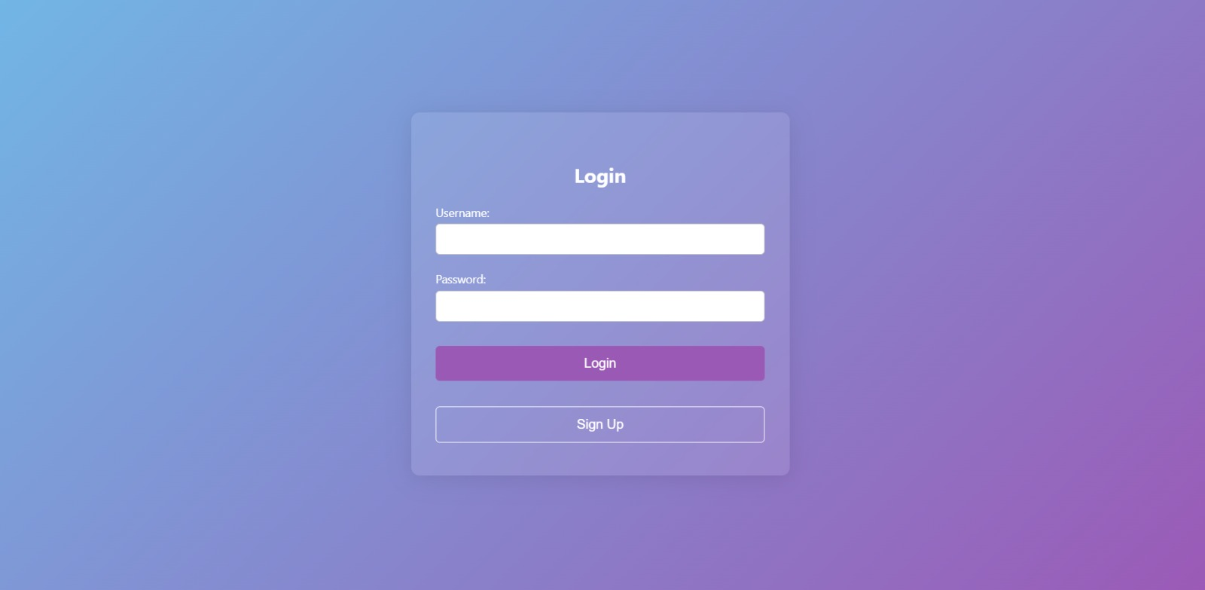

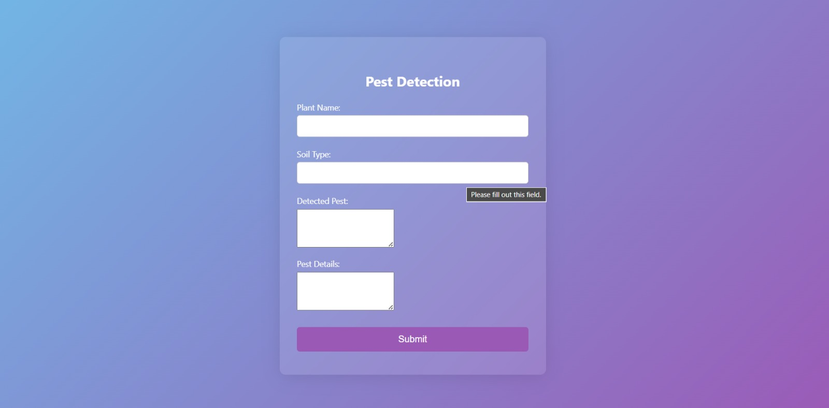

**CONCLUSION**

The Pest Detection Management System, developed using Flask, represents a significant advancement in agricultural technology, offering farmers a streamlined method to report and manage pest sightings. Traditional pest management techniques often involve manual monitoring and delayed responses, leading to increased crop damage and reduced yields. This web-based application addresses these challenges by providing a centralized platform where farmers can quickly report pest occurrences, ensuring timely data collection and response.

Centralizing pest data is crucial for effective pest management. By aggregating reports from various sources, the system can analyze trends and predict potential pest outbreaks. This predictive capability allows for proactive measures, reducing the reliance on harmful pesticides and promoting more environmentally friendly pest control methods. The real-time updates and advice provided by the system empower farmers with the information they need to take immediate action, thereby mitigating the impact of pests on their crops.

Moreover, the Pest Detection Management System supports sustainable agricultural practices by encouraging integrated pest management (IPM) techniques. IPM emphasizes the use of a combination of biological, cultural, mechanical, and chemical methods to control pests in the most sustainable way possible. By providing expert guidance and best practices through the application, farmers can implement these techniques more effectively. This holistic approach not only helps in controlling pest populations but also preserves the ecosystem and enhances soil health.

The development of this web-based application highlights the potential of technology in enhancing agricultural sustainability. By leveraging modern tools such as Flask for backend development and integrating robust data management practices, the project sets a precedent for future innovations in agriculture. The system's ability to provide timely, accurate, and actionable information underscores the transformative role of technology in ensuring food security and promoting sustainable farming practices.

**FUTURE SCOPE**

Future enhancements for the Pest Detection Management System can significantly expand its capabilities and effectiveness in supporting farmers and promoting sustainable agricultural practices:

1. **Integration with a Database**
   * **Persistent Storage**: Transition from in-memory storage to a robust database like SQLite or PostgreSQL for secure and scalable storage of pest data.
   * **Data Analysis**: Enable advanced data analytics and reporting capabilities, allowing for deeper insights into pest trends and patterns over time.
2. **Implementation of Machine Learning Models**
   * **Automated Pest Detection**: Introduce machine learning algorithms to automate the detection and identification of pests from reported data.
   * **Predictive Analytics**: Utilize historical data to develop predictive models that anticipate pest outbreaks, enabling proactive pest management strategies.
3. **Expansion of User Interface**
   * **Detailed Pest Management Advice**: Enhance the user interface to provide comprehensive guidance on pest control techniques, integrated pest management (IPM) strategies, and sustainable farming practices.
   * **Educational Resources**: Include resources such as articles, videos, and tutorials to educate farmers on effective pest management techniques.
4. **Mobile Application Development**
   * **Field Accessibility**: Develop a mobile application companion to the web-based system, allowing farmers to report pest sightings and access management advice directly from the field.
   * **Offline Functionality**: Ensure the application works offline, syncing data once connectivity is restored, to accommodate areas with limited internet access.
5. **Incorporation of IoT Devices and Sensors**
   * **Real-Time Monitoring**: Integrate IoT devices and sensors to monitor pest activity in real time across agricultural fields.
   * **Alert Systems**: Implement alert systems that notify farmers of sudden changes in pest populations or environmental conditions, enabling prompt responses and minimizing crop damage.

These enhancements aim to leverage technology to improve the efficiency, accuracy, and accessibility of pest management practices. By integrating advanced data analytics, automation, and mobile accessibility, the system can empower farmers with the tools and information needed to make informed decisions and mitigate the impact of pests on agricultural productivity.